**UNIT 18**

**WHAT WILL THE WEATHER BE LIKE TOMORROW?**

**I.Listen and check the box**.

1. What’s the time?

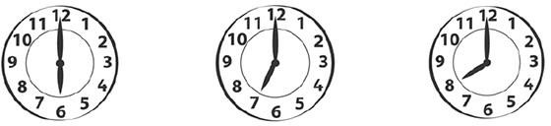

**A**

**B**

**C**

1. What does he like?

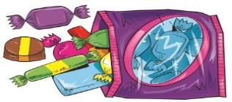

**C**



**B**



**A**

1. When have we got P.E?



**C**



**B**



**A**

1. What’s the weather like ?

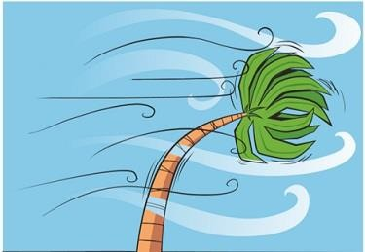

**A**

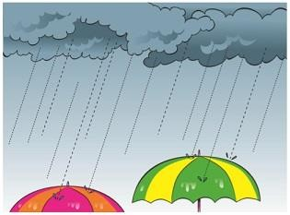

**B**

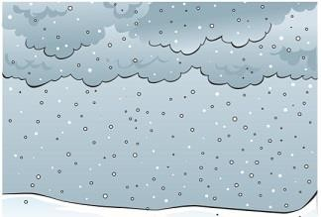

**C**

**II.Listen and match. There is one example.**

|  |  |  |
| --- | --- | --- |
| https://kiemtra.sachmem.vn/images/ta52/u18/media/image1.jpeg  **A.** | https://kiemtra.sachmem.vn/images/commons/fe.png | https://kiemtra.sachmem.vn/images/ta52/u18/media/image2.jpeg  **D.** |
| https://kiemtra.sachmem.vn/images/ta52/u18/media/image3.jpeg  **B.** | https://kiemtra.sachmem.vn/images/ta52/u18/media/image4.jpeg  **E.** |
| https://kiemtra.sachmem.vn/images/ta52/u18/media/image5.jpeg  **C.** | https://kiemtra.sachmem.vn/images/ta52/u18/media/image6.jpeg  **F.** |